Pre-K School Supplies
Supplies |  | Útiles | Quantity
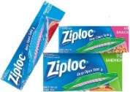  Gallon & snack size Ziplock bags (girls)  Sandwich & quart size Ziplock bags  (boys) |  | Caja de bolsas Ziplock tamaño galón y snack (niñas)  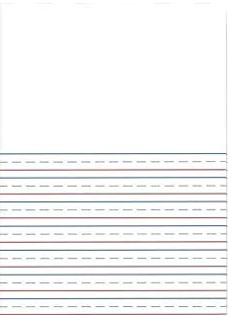  Caja de bolsas Ziplock tamaño sándwich y quarto (niños) | 2
Primary Composition book  (white space on top with lines  on bottom) | 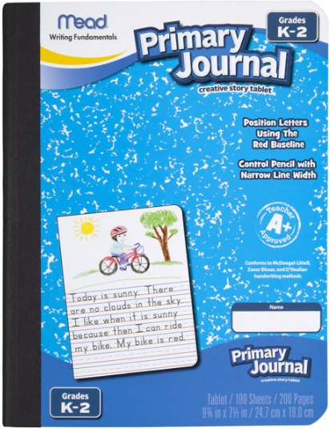 | Libro de composición primaria  (con espacio blanco arriba y líneas abajo) | 2
Packs of manila (not colored) construction paper (12x18) |  | Paquetes de papel de construcción de varios colores (12x18)  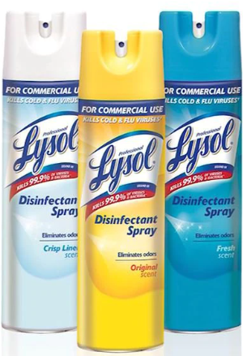 | 2
Can of Lysol Disinfectant Spray |  | Lata de aerosol desinfectante Lysol | 1
Large bottle of hand sanitizer (no water required)  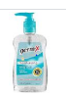 |  | Botella grande de desinfectante para manos (que no requiere agua) | 1
Boxes of Crayola brand crayons size large or jumbo |  | Cajas de crayolas de colores marca Crayola  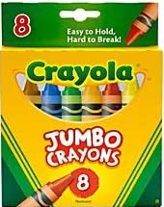  tamaño grande o jumbo | 2
4 pack of Playdoh brand playdough |  | Paquete de 4 botes de plastilina marca Playdoh | 2
Packs of baby wipes  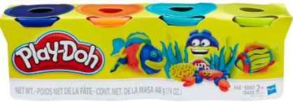 |  | Toallitas de bebé  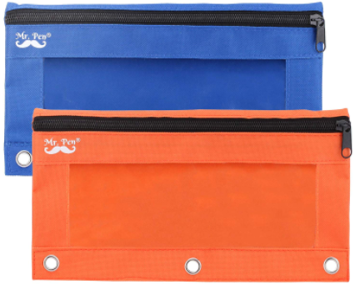 | 2
Pencil pouch with zipper (no pencil boxes) |  | Bolsa con cierre para guardar los lápices (no caja de lápices) | 1
Package of glue sticks | 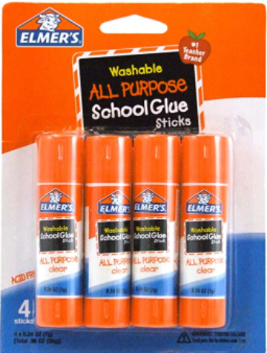 | Paquete de pegamento de tubo (“glue sticks”) | 1
Box of Kleenex | 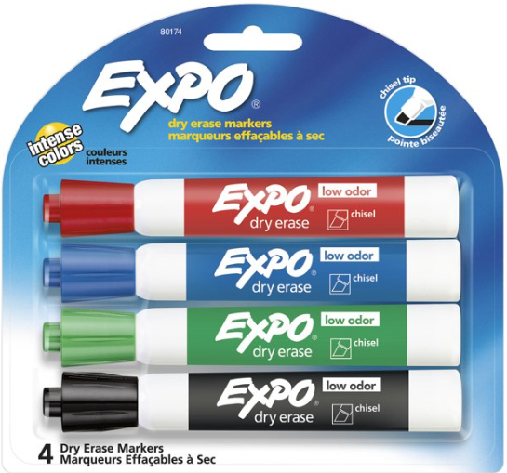 | Caja de Kleenex | 1
4 pack of dry erase markers (chisel tip) |  | Paquete de 4 marcadores de borrado en seco (punta biselada) | 1
Blanket or towel for nap time | 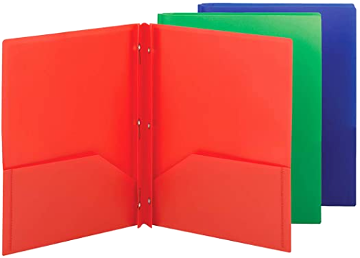 | Cobija o toalla para la hora de la siesta | 1
Poly(plastic) pocket folder with brads choose 2 colors (red, yellow, green, blue, orange) |  | Carpeta de plástico con bolsillos y clavitos, elija 2 colores (rojo, amarillo, verde, azul) | 2
Student Backpack |  | Mochila para el estudiante | 1
*All Pre-K parents should send 1 FULL set of uniform clothes (including socks and underwear) that are labeled with your child’s name. These should be sent on the very first day or even dropped off at Meet-and-Greet in August. Throughout the year parents are expected to send new emergency clothes EVERY time they are used in case of an accident.

*Los padres deben enviar un uniforme completo (incluyendo calcetines y ropa interior) que esté marcado con el nombre de su hijo empezando en agosto. A lo largo del año, se espera que los padres envíen ropa nueva en caso de tenga un accidente.
Kindergarten School Supplies
Supplies |  | Útiles | Quantity
Gallon & snack size Ziplock bags (girls)  Sandwich & quart size Ziplock bags  (boys) |  | Caja de bolsas Ziplock tamaño galón y snack (niñas)  Caja de bolsas Ziplock tamaño sándwich y quarto (niños) | 2
Primary Composition book  (white space on top with lines  on bottom) |  | Libro de composición primaria  (con espacio blanco arriba y líneas abajo) | 4
Packs of manila and colored construction paper (12x18) |  | Paquetes de papel de construcción de manila y varios colores (12x18)  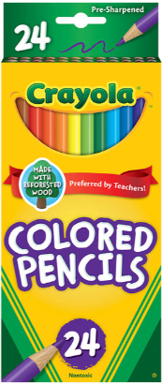 | 1 each
Box of Colored pencils (map pencils) |  | Caja de lápices de color | 1
Large bottle of hand sanitizer (no water required) |  | Botella grande de desinfectante para manos (que no requiere agua) | 1
Boxes of Crayola brand crayons 16 or 24 count |  | Cajas de crayolas de colores marca Crayola  de 16 o 24 crayones | 2
24 Pack of #2 Pencils (plain, no design) |  | Paquete de 24 botes lápices del #2  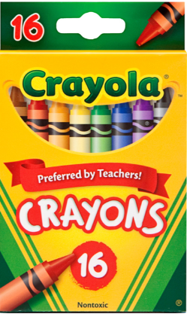  (normal, sin diseños) | 1
Packs of sanitizing wipes |  | Toallitas para desinfectar las manos (no de bebe) | 2
Blue Pencil boxes (10 x 8 x 7in) |  | Caja azul para lápices (10 x 8 x 7in) | 1  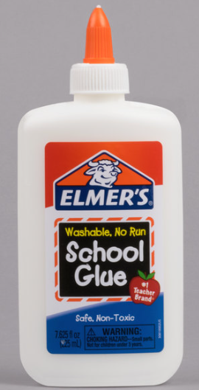
Large bottle of liquid glue | 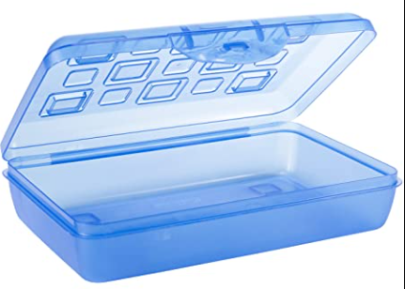 | Botella grande pegamento liquido | 2
Boxes of Kleenex | 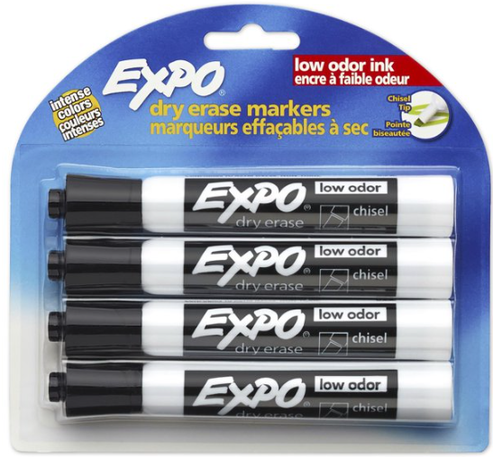 | Cajas de Kleenex | 2
4 pack of dry erase markers (chisel tip, black only) |  | Paquete de 4 marcadores de borrado en seco (punta biselada y solo negros) | 1
Blunt tip scissors (rounded end) | 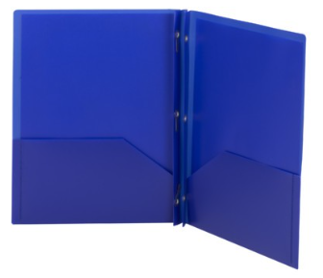 | Par de Tijeras con punta redonda | 1
Blue Poly(plastic) pocket folder with brads |  | Carpeta azul de plástico con bolsillos y clavitos | 2
Large erasers |  | Borradores Grandes | 2
White 1 inch hard cover Binder |  | Carpeta blanca de 1 pulgada de cubierta dura | 1
Student Backpack |  | Mochila para el estudiante | 1
*All Pre-K parents should send 1 FULL set of uniform clothes (including socks and underwear) that are labeled with your child’s name. These should be sent on the very first day or even dropped off at Meet-and-Greet in August. Throughout the year parents are expected to send new emergency clothes EVERY time they are used in case of an accident.

*Los padres deben enviar un uniforme completo (incluyendo calcetines y ropa interior) que esté marcado con el nombre de su hijo empezando en agosto. A lo largo del año, se espera que los padres envíen ropa nueva en caso de tenga un accidente.

